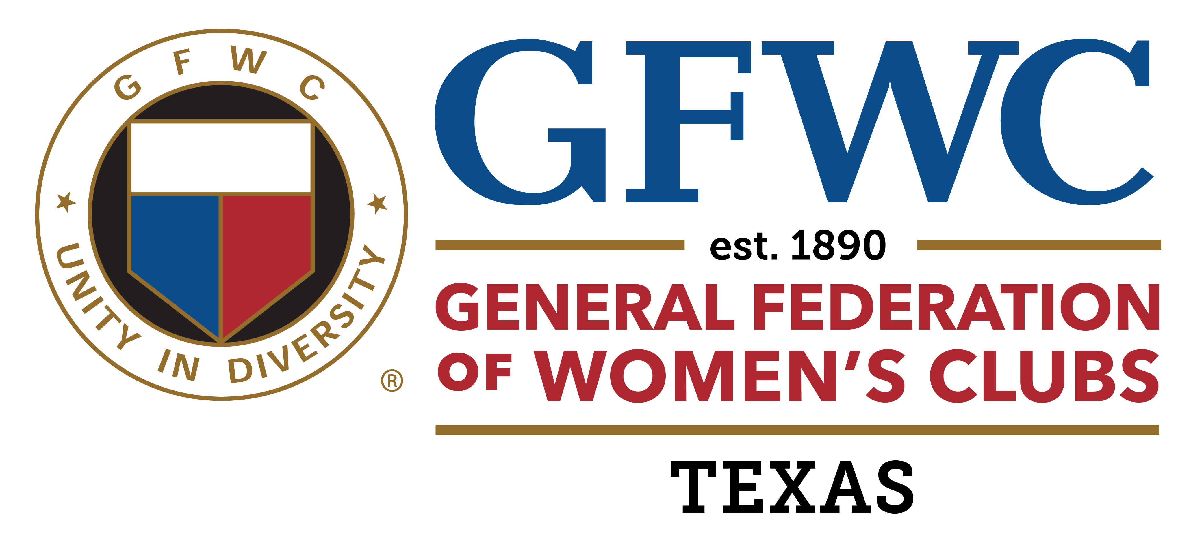

GFWC Texas LEADS

Leadership and Development Seminar

Class of 2025

September 19, 2024

Doubletree by Hilton Hotel Austin Northwest Arboretum

Jennings Room

8901 Business Park Drive

Austin, Texas 78759

12:30 – 3:00 p.m.

Topics to be included in this training for incoming leaders, potential leaders and interested members include:

* GFWC History and Guides
* Team building
* Conducting Meetings
* Transition During Programs Planning
* Public Speaking
* Script Writing
* Succession of Officers Planning

This is the first GFWC Texas LEADS meeting, which will be continued via Zoom meetings throughout the year. The final meeting/graduation will be held on April 30, 2025, preceding the GFWC Texas Spring Convention in Corpus Christi.

There is no charge for this seminar. GFWC Texas members are encouraged to apply before September 1, 2024. District Presidents-elect and club presidents are strongly encouraged to submit an application. The number accepted for the first class will be limited to 20. Members who have attended GFWC LEADS are not eligible at this time.

If you have any questions, call GFWC Texas LEADS chairman Lou Hitt at 817-996-9030. Send applications to [hittlou@yahoo.com](mailto:hittlou@yahoo.com) or PO Box 1773, Decatur, Texas 76234.

Deadline September 1, 2024